The Experiment.

As my final year project at Plymouth University I am carrying out an experiment to test a hypothesis that it is the accessibility (through portable computing ie: mobile phones) of social media, that drives users to be “hooked” into social media use through certain motivational principles.

I am asking for support during the processes as my own Facebook will be the subject area for testing, needing, as it does a working active, social media platform from which I can gather comparative data.

### The Technology

I have retro-fitted a modern Raspberry Pi 3 microcomputer, capable of navigating the internet in much the same way as a mobile phone, into a mid-1980’s portable media station. This device was never meant to be carried throughout the day and used for social media. To give some context to this; mobile phones of the era were huge 1 kg analogue devices.

### The big idea

The intent of the project, is to *subvert* a set of accepted physical and functional characteristics of technology within social media use on a day to day basis. The structure of the project has been built around the concept of making a physically obtrusive and technically challenging device, which could be used to explore the character of social media and its pervasive accessibility.

The area for research and the resulting technical build, within this project, is a commentary and experiment on the ubiquitous nature of the mobile internet and its resulting normalising of emerging isolating behaviours. From a choice of several major online activities, social media and in particular its usage on mobile devices, stood out as the most suitable as regards its requirement for constant revisiting, a phenomenon known as the Fear Of Missing Out ( Patrick J. McGinnis,2004)

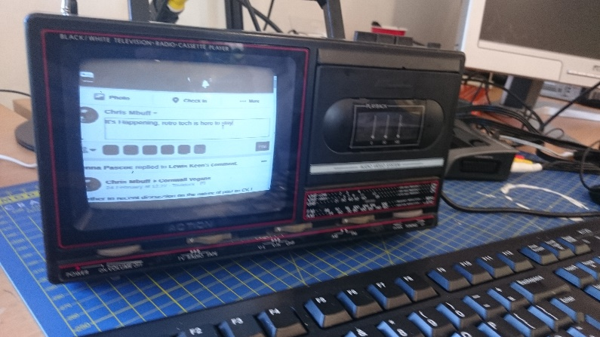

Figure mobieThe Action device with Mobile Facebook through Chrome

By designing a forced process: setting up the equipment, tethering to a mains supply, digital to radio signal conversion, the near illegibility of the text on a low fidelity screen, physically tuning into the Facebook channel, the whole immediacy of the social media posting process it slowed down. And through this slowing down a more deliberate, measured approach to social media actions, I aim to define a set of measurable processes to compare against my standardised historical use of the media.

It also my intention to post (re-post) if possible my own feed and see if that then generates its own momentum. I hope that the majority of my followers will stick with me through what may be a month-long experiment, where I am hoping for some notable results, this project will account for a significant portion of my final marks.

Chris Maycock BSc (Hons) Internet Design . Final Year Project

## Disclaimer

### Chris Maycock BSc. (Hons) Internet Design: Social Media Guidelines

As part of my final year degree project and technical report I will be analysing my social interactions through my personal Facebook account. This experiment is about both the qualitative and quantitative nature of social media use and is NOT about gathering the actual post and text of other parties that “follow” my posts or that I follow. Any post from outside parties will be only included to give context to my own posts (if at all necessary)

I ask that you’re free in your comments in so much as you post any comments as you would prior to the ensuing experiment. I reserve the right to remove anything I deem:

* Not suitable for the gathering of data
* Material that is unlawful, obscene, defamatory, threatening, harassing, abusive, slanderous, hateful or embarrassing to any other entity
* Third party advertising
* Chain posts or ‘spam’

I also reserve the right to terminate involvement by users who post such content. The views and opinions expressed on my social media sites do not necessarily represent those of the University of Plymouth. Therefore, that body cannot be held responsible for the accuracy or reliability of information posted by myself. For your safety, never include your phone number, email, address or other personal information in a post. Your comments will visible to all (although username and profiles will not and never shall be), unless stated to me via messenger or email as needing to be excluded.

ALL posts will be anonymous, except my own, and any content that is not purely offering context to my own posts will not be used, preserving the safety and secure integrity of all followers posts. My Facebook profile is not public and therefore not viewable outside of the parameters of Facebook and it is the wish of myself that you do not share my posts without due permissions being granted. However the accompanying blog <https://chrismbuff.wixsite.com/fomo/life-with-action> will be public, again all users names, profiles or identifiable data will be anonymous. Any sensitive posts will not be shared with particular reference to activism, personal issues (other than my own) in order to preserve integrity and safety for all parties.If you do not wish any of your own material used for the report, the Facebook page or the accompanying website blog please notify me immediately and your posts will not be included, other than as an anonymous statistic based on the Wolfram Facebook metrics. [<http://www.wolframalpha.com/facebook/>]. For further clarity on the project please do not hesitate to contact me.

Facebook profile name ChrisMbuff https://www.facebook.com/chris.mbuff

Email Christopher.Maycock@students.plymouth.ac.uk